**RAJALAKSHMI ENGINEERING COLLEGE**

**RAJALAKSHMI NAGAR, THANDALAM – 602 105**



|  |
| --- |
| **CS23A34**  **USER INTERFACE AND DESIGN LAB** |
| **Laboratory Observation NoteBook** |

|  |
| --- |
| **Name :** SREE VARSSINI K S  **Year/Branch/Section :** II/CSE/D  **Register No. :** 230701332  **Semester :** IV  **Academic Year:** 2024-25 |

**Ex. No. : 5a**

**Register No. : 230701332 Name : Sree Varssini K S**



**Simulate the lifecycle stages for UI design using the RAD**

**model and develop a small interactive interface using Axure**

**RP.**

**Aim:**

The aim is to demonstrate the lifecycle stages of UI design via the RAD model and develop a small interactive interface employing Axure RP.

**Procedure:**

### RAD Model (Rapid Application Development): The RAD model emphasizes quick development and iteration. It consists of the following phases:

### Requirements Planning:

### Gather initial requirements and identify key features of the UI.

### Engage stakeholders to understand their needs and expectations.

### User Design:

### Create initial prototypes and wireframes.

### Conduct user feedback sessions to refine the designs.

### Use tools like Axure RP to develop interactive prototypes.

### Construction:

### Develop the actual UI based on the refined designs.

### Perform iterative testing and feedback cycles.

### Cutover:

### Deploy the final UI.

### Conduct user training and support.

### Axure RP Interactive Interface Development

#### Phase 1: Requirements Planning

### Identify Key Features:

### Navigation (Home, Product Categories, Product Details, Cart, Checkout, Order Confirmation, Order History)

### User actions (Browsing, Searching, Adding to Cart, Checkout, Tracking Orders)

### Create a Requirements Document:

### List all features and functionalities.

### Document user stories and use cases.

#### Phase 2: User Design

### Install and Launch Axure RP:

### Download and install Axure RP from Axure's official website.

### Launch the application.

### Create a New Project:

### Go to File -> New to create a new project.

### Name the project (e.g., "Shopping App Interface").

### Create Wireframes:

### Use the widget library to drag and drop elements onto the canvas.

### Design wireframes for each screen:

### Home Page

### Product Categories

### Product Listings

### Product Details

### Cart

### Checkout

### Order Confirmation

### Add Interactions:

### Select an element (e.g., button) and go to the Properties panel.

### Click on Interactions and choose an interaction (e.g., OnClick).

### Define the action (e.g., navigate to another screen).

### Create Masters:

### Create reusable components (e.g., headers, footers) using Masters.

### Drag and drop masters onto the wireframes.

### Add Annotations:

### Add notes to describe each element's purpose and functionality.

### Use the Notes panel to add detailed annotations.

#### Phase 3: Construction

### Develop Interactive Prototypes:

### Convert wireframes into interactive prototypes by adding interactions and transitions.

### Use dynamic panels to create interactive elements (e.g., carousels, pop-ups).

### Test and Iterate:

### Preview the prototype using the Preview button.

### Gather feedback from users and stakeholders.

### Make necessary adjustments based on feedback.

#### Phase 4: Cutover

### Finalize and Export:

### Finalize the design and interactions.

### Export the prototype as an HTML file or share it via Axure Cloud.

### User Training and Support:

### Conduct training sessions to familiarize users with the new interface.

### Provide documentation and support for any issues.

**Output:**

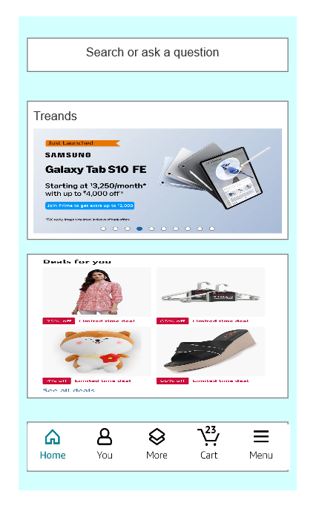 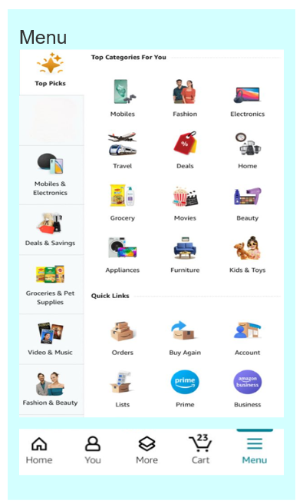

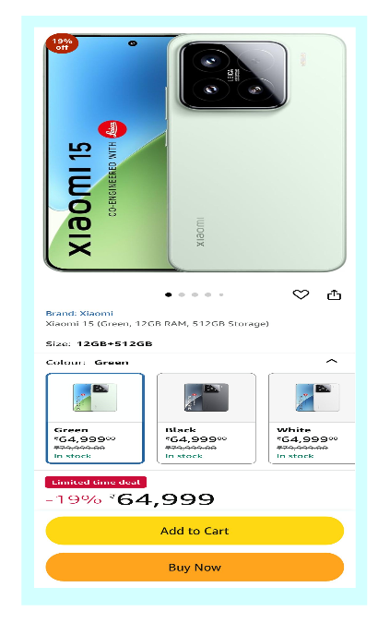 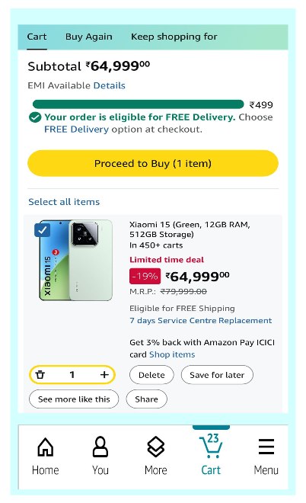

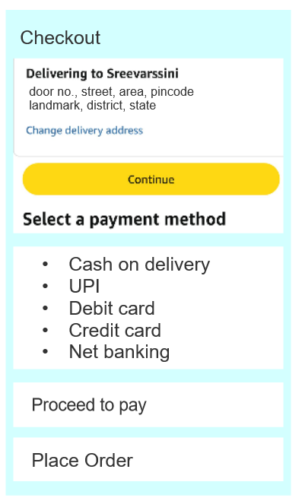 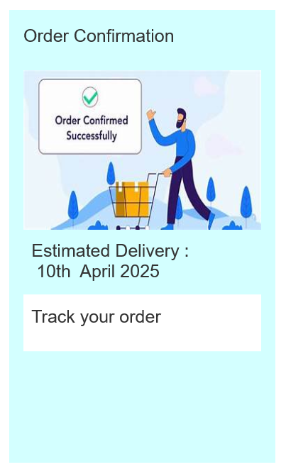

**Result:**

Hence the task analysis and documentation for a online shopping app has been successfully done with the help of Dia.